**Effects of CO2 emissions on the weather in USA by State**

Parth Patel - ppatel92@gatech.edu

Kenny Wu - kwu70@gatech.edu

Shafiq Mohammed - [shafiq@gatech.edu](mailto:shafiq@gatech.edu)

CO2 emissions data set: - <http://epa.gov/statelocalclimate/resources/state_energyco2inv.html>

Average temperature data set: <http://www.ncdc.noaa.gov/cag/>

**Domain**

The domain that we are targeting for this project is the relationship between a state’s CO2 emissions by type and the changes observed in the weather for that state over time. The dataset found during our initial research allows us to target this domain as it shows data dissolved into different types of emissions associated with each state. This visualization will primarily be targeted towards scientific research performed in the field of different types of CO2 emissions and their effect on the atmosphere.

**Task**

The visualization should be able to provide tools to a user with which he can compare and summarize different pieces of information associated with each state and observe changes in weather trends correlated with the CO2 emissions generated by each state over time. For example, the user will either be able to observe a static temperature in a specific year for a state or for all states, or the user can observe a trend, a change in weather for all states over a time series representation of the data. The user can compare a trend observed in CO2 emissions by each state over 2 decades, and compare that to a trend observed in climate for each state to summarize if CO2 emissions affect climate, or what type of CO2 emissions specifically cause a negative effect on the climate in a more drastic manner when compared to other types of CO2 emissions.

**Dataset**

The dataset for CO2 emission contains five categories for each state in the US. Ranging from 1990 to 2012, the dataset shows emission for commercial, industrial, residential, transportation, and electric power in million metric tons unit. The dataset will allow us to determine which state have the highest or lowest CO2 emission and to calculate the average CO2 emission in the US for a particular year. Using the CO2 emission data, we will mapped out the change in temperature along with the change in the CO2 emission. The weather data will be acquired from National Oceanic and Atmospheric Administration (NOAA) for the year of 1990 to 2012 for every contiguous 48 states. What we are mainly looking for in this weather data set is the average temperature attribute for each year in the contiguous 48 states in United State.

**Personal Expertise**

None of our group members know about this area of work at all, however, global warming is a very interesting topic that is especially popular in our times. Being able to truly determine whether a correlation between CO2 emissions and temperature change exists seems like a problem that each one of us wants to tackle and figure out.

**Proposed Solution**

Our proposed solution consists of multiple idioms to display different aspects of our data. First, the user will be able to select a year range to display the respective data for those years. Next, the user will choose a state for our detailed insight idiom.

Once the user has made his selections, our system will generate three idioms. For the first idiom, we will have a choropleth graph displaying the state-by-state map of the United States with the average temperature data encoded by year. For the second idiom, we will have a choropleth graph displaying the state-by-state map of the United States with the average CO2 emissions encoded by the year. Finally, we will have a multiple line graph idiom which will encode both the average temperature and the average CO2 emissions for a selected state for the selected range of years.

In essence, the choropleth graphs give a broad overview of the temperature and CO2 differences for the selected years, while the multiple line graph gives us a breakdown of the correlation between temperature and CO2 emissions for either an individual state or for the entire United States across those years.

**Scenario of Use**

* Assume, that I want to view the state with the highest CO2 emission for a certain year, but I also want to view the state’s trend for a range of years in line chart form which also allows me to visualize a trend line for a range of years for the temperature of that state.
  + The system itself will start out by visualizing the comparison of CO2 emissions for all contiguous 48 states in US for a certain year in the form of two heat maps on the left side of the vis space and two temperature heat maps in the same manner on the right side of the vis space.
  + The user can then click on a certain state on the heatmap that appears to have the highest quantitative value, because the user will be able to clearly distinguish the state separation by boundaries as we plan to implement a US map with boundary separation and color encoded quantitative values that will also allow use interaction.
  + When the user selects a state with the highest CO2 emissions for a certain year from the heatmap, the visualization will transition from a heatmap to line chart form which will show two trend lines on a graph that will represent CO2 emissions and temperatures respectively, for a range of years, which will allow the user to observe a trend in the data comparison, if there exists one.
  + In the lower right corner, in case the user decides to view a trend for a different range of years, or for a different state, there will exist a set of buttons to perform this task.
  + The same screen will also have a button associated with the functionality of taking the user back to the heatmaps.

**Illustrations/Mockups**

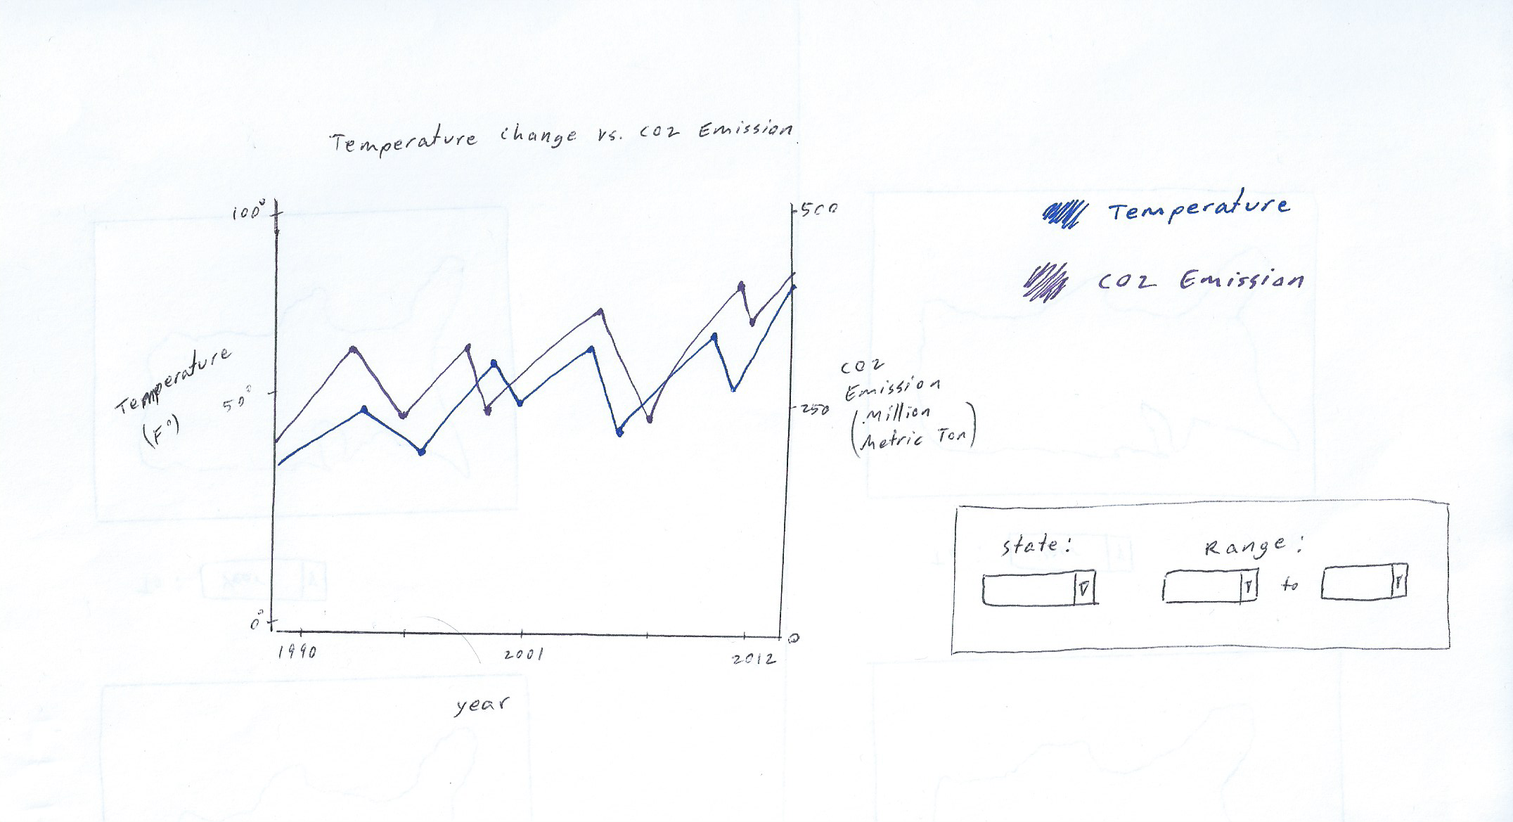

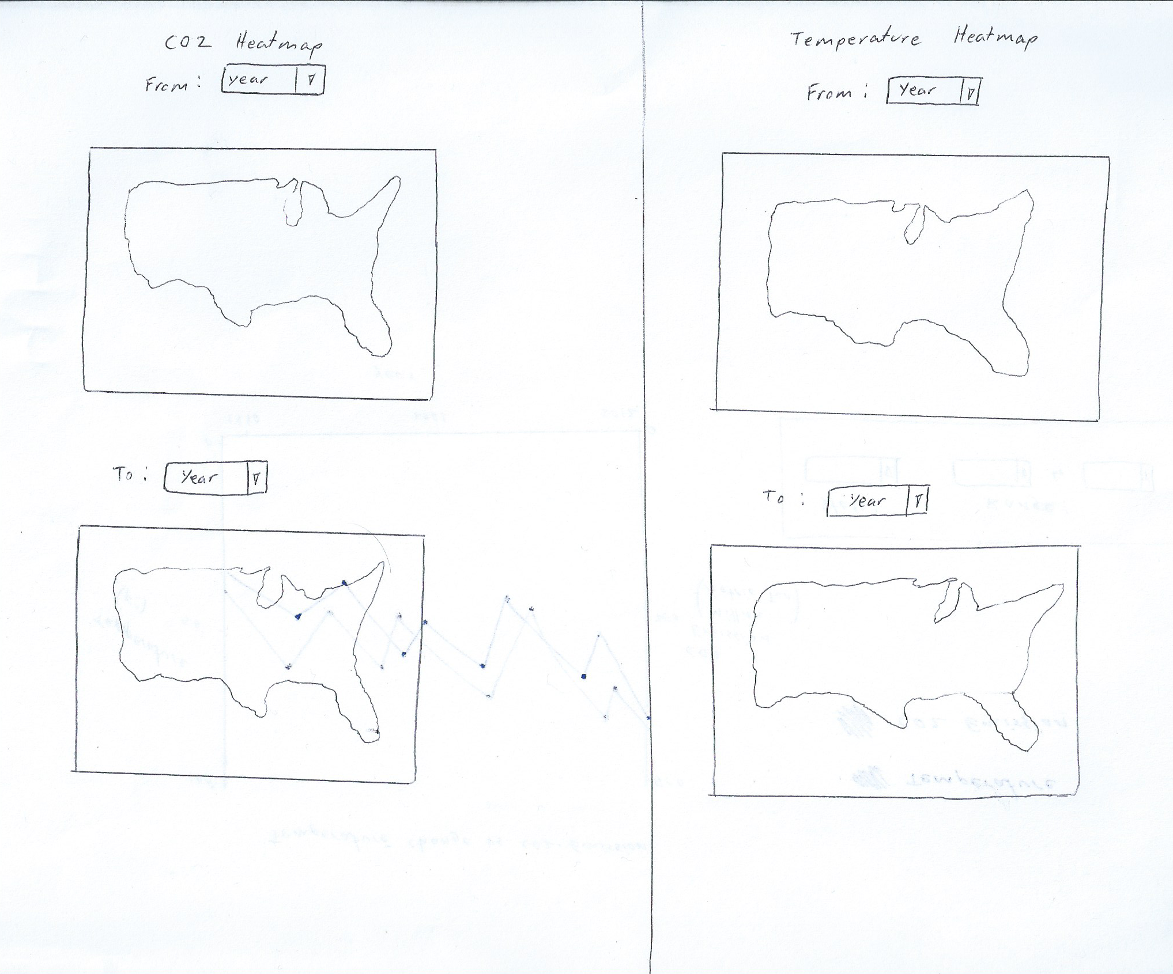

**Proposed Implementation and Approach**

We will build a web-based solution to the above problem using the D3 Javascript framework.

**Milestones and Schedules**

June 26- Milestone 1: Requirements gathering milestone. This entails the team learning about D3 and coming up with a tangible idea on how to approach our solution with code in mind.

June 30- Milestone 2: Have the first idiom, the two choropleth graphs which display the temperature data developed and functioning

July 3- Milestone 3: Have the second idiom, the two choropleth graphs which displays the CO2 emissions data developed and functioning.

July 8th- Milestone 4: Have the third idiom, the multiple line graph which helps us see the trends of both the average temperature range and CO2 emissions encoded.

July 12th- Milestone 5: Have all 3 idioms put into one system and work out bugs in the system. Testing should be done and the system should be completed.

July 15th- Milestone 6: Have the presentation video created.

**Previous Work**

***1. Planet Seed***

This website contains a brief overview of CO2 emissions globally, and then proceeds to provide an idiom in the form of a multiple line graph that outlines the relationship between CO2 emissions and global temperature change. While this may look similar to ours, this infovis consists of a broad overview of the world temperature

***2. Environmental Protection Agency:*** <http://www.epa.gov/climatechange/ghgemissions/global.html>

The environmental protection agency website has constructed several charts which reflect CO2 emissions from fossil fuels from the years 1900-2008 globally and by the countries that are the largest contributors of CO2 emissions. Even though our project is geared towards analyzing this data in the light of weather change, this may prove to be a good source to get us started since it will give us an idea of what type of data to anticipate and analyze.

**3. NASA**

<http://climate.nasa.gov/>

The climate section of NASA’s website provides great information about various sorts of data relating to climate around the world. Data such as global temperature change from the 1880s up till 2010 and global carbon dioxide levels in parts per million from 2005 - 2015 would provide great insight into the type of data that we will be observing. Even though at face value this may seem greatly similar to our project, NASA has created different infographics that reflect these changes. Whereas in our project, we are seeking to merge these two fields together in order to create a visualization where a user can easily see whether a correlation exists between CO2 emissions and temperature changes across the united states.